Assignment-based Subjective

Question 1: From your analysis of the categorical variables from the dataset, what could you infer about their effect on the dependent variable? (3 marks)

Answer:
Year vs Count
- 2019 has significantly higher counts than 2018.
- Insight: Overall bike usage increased in the second year. Could be due to growth in service usage or better promotion.
Season vs Count
- Summer and Fall show higher median counts compared to Spring and Winter.
- Spring has the lowest median and a few outliers.
- Insight: Bike rentals are most popular in Fall and Summer, likely due to better weather.
Month vs Count
- Usage peaks from May to September, with July highest.
- December–February shows the lowest rentals.
- Insight: There is a clear seasonal pattern, with peak usage in warmer months.
Holiday vs Count
- Non-holidays have slightly lower median count but fewer outliers.
- On non-holidays, the booking count tends to be lower, which is reasonable as people may prefer spending time at home with family during holidays.
Weekday vs Count
- Distributions are quite similar for working and non-working days.
- Insight: Weekdays do not heavily influence rentals. Maybe a mix of work and leisure usage.
Working day vs Count
- Distributions are quite similar for working and non-working days.
- Insight: Rentals happen regardless of working status. Suggests strong non-commute-related usage too.
Weather Situation vs Count
- Clear weather has the highest median and wider distribution.
- Snowy weather sees the lowest usage.
- Insight: Weather significantly affects usage. Clear days encourage bike rentals, while snow suppresses them.

Question 2. Why is it important to use drop_first=True during dummy variable creation? (2 mark)
Answer
Dummy variable creation is a technique used in stats modelling and machine learning to represent categorical variables with binary values (0 or 1). It involves creating new binary (dummy) variables for each category of the original categorical variable. These dummy variables serve as indicators for the presence or absence of a specific category.
The number of dummy variables to create depends on the number of categories in the original categorical variable. For a categorical variable with N categories, you typically create N − 1 dummy variables.
Using drop_first=True avoids the dummy variable trap, which occurs when all categories are included, leading to multicollinearity. Dropping the first category removes redundancy and ensures the model remains stable and interpretable.
For example, if you have a variable "Color" with categories "Red," "Blue," and "Green," you would create two dummy variables, say "Is_Blue" and "Is_Green." The absence of both dummy variables implies that the color is "Red."

Question 3. Looking at the pair-plot among the numerical variables, which one has the highest correlation with the target variable? (1 mark)
Answer:
The variable 'temp' exhibits the strongest correlation with the target variable. Given that 'atemp' and 'temp' are redundant variables, only one of them is selected during the determination of the best fit line.

Question 4. How did you validate the assumptions of Linear Regression after building the model on the training set? (3 marks)
Answer:
Validating the assumptions of linear regression is a crucial step to ensure the reliability of the model. After building the model on the training set, here are the steps I followed to validate the assumptions:
Residual Analysis:
- Process: Examine the residuals i.e., errors (the differences between observed and predicted values).
- Check: Residuals should be approximately normally distributed, and there should be no discernible patterns in the residual plot.
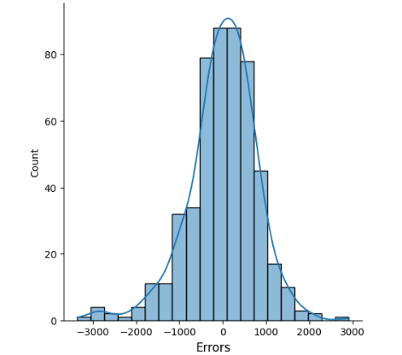

Homoscedasticity (Constant Variance):
- Process: Plot residuals against predicted values
- Check: The spread of residuals should be roughly constant across all levels of the predicted values.

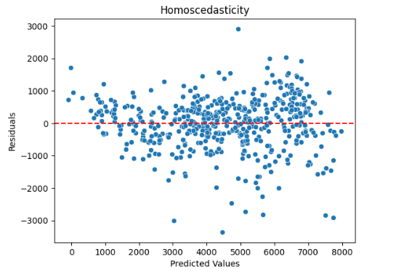

Linearity:
- Process: Create a scatterplot of observed vs. predicted values
- Check: The points should fall approximately along a diagonal line, indica>ng a linear relationship.
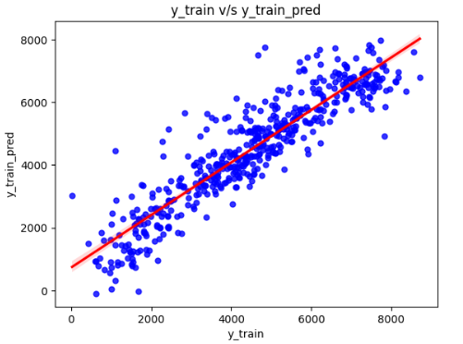

Question 5. Based on the final model, which are the top 3 features contributing significantly towards explaining the demand of the shared bikes? (2 marks)

Answer:
The equation of the best fit line is given by:
cnt = 4491.30 + 995.75 x yr + -133.20 x holiday + 1120.81 x temp -226.30 x hum -272.75 x windspeed + 341.16 x Summer + 527.80 x Winter + 252.23 x September -204.50 x Cloudy -339.317 x Snow

Based on the final linear regression model, the top 3 features contributing significantly towards explaining the demand for shared bikes are:
- Temperature (temp) – Coefficient: +1120.81
Indicates that as temperature increases, bike demand increases substantially.
- Year (yr) – Coefficient: +995.75
Shows that bike demand significantly increased in the second year (2019 compared to 2018).
- Winter (season Winter) – Coefficient: +527.80
Suggests that winter season saw a strong positive impact on bike usage, possibly due to improved infrastructure or sustained demand.
These features have the largest positive coefficients, indicating a strong positive relationship with bike rental count (cnt).

General Subjective

Questions 1. Explain the linear regression algorithm in detail. (4 marks)
Answer:
Linear Regression is a supervised learning algorithm used for predicting a continuous target variable based on the relationship between independent (predictor) variables and a dependent (target) variable. It assumes a linear relationship between them.

1. Equation of a Linear Regression Model:
For a simple linear regression:
$$y=β0​+β1​x+ε$$
For multiple linear regression:
$$y=β0​+β1​x1​+β2​x2​+⋯+βn​xn​+ε$$

Where:
• y = dependent variable (target)
• x1, x2…xn​ = independent variables (features)
• β0​ = intercept (bias)
• β1, β2 ​,...,βn​ = coefficients (slopes)
• ε = error term (residual)

2. Objective of Linear Regression:
The goal is to find the best-fitting line (or hyperplane) that minimizes the difference between the actual values and the predicted values.
This is done by minimizing the cost function, typically the Mean Squared Error (MSE):
$$MSE=n1​∑(yi​-y^​i​)2$$
3. Assumptions of Linear Regression:
To ensure valid results, linear regression assumes:
- Linearity: The relationship between independent and dependent variables is linear.
- Independence: Observations are independent of each other.
- Homoscedasticity: Constant variance of residuals across all values of predictors.
- No multicollinearity: Predictors are not highly correlated.
- Normality: Residuals (errors) are normally distributed.
4. Interpretation:
- The intercept (β0​) indicates the predicted value of y when all xi=0.
- The coefficients (βi ​) represent how much y is expected to change when xi increases by one unit, holding all other variables constant.
Conclusion:
Linear regression is a simple, interpretable, and widely used algorithm for prediction and trend analysis. When its assumptions are met, it provides reliable and statistically meaningful results.

Question 2. Explain the Anscombe’s Quartet in detail.
Answer:
Anscombe’s Quartet consists of four datasets that have nearly identical statistical properties:
- Same mean and variance for x and y
- Same correlation coefficient
- Same linear regression line
However, their scatter plots reveal very different distributions:
- One linear
- One non-linear
- One with an outlier
- One with a vertical line of data
Conclusion: It shows the importance of data visualization. Statistical summaries can be misleading without plots.

Question 3. What is Pearson’s R?
Answer:
Pearson’s R is the correlation coefficient that measures the strength and direction of a linear relationship between two continuous variables.
- Ranges from -1 to +1
  - +1 = perfect positive correlation
  - 0 = no linear correlation
  - -1 = perfect negative correlation
Formula:
R = cov(X,Y)​ / σX​⋅σY​
Used in regression to detect multicollinearity and analyse variable relationships.

Question 4. What is scaling? Why is it performed? What is the difference between normalized and standardized scaling?
Answer:
Scaling is the process of adjusting feature values to a common scale.
Why it's performed:
- Ensures fair weight in models i.e., Features like age (0–100) and salary (10,000–100,000) have different scales. Without scaling, large-scale features dominate the model.
- Improves convergence of gradient-based algorithms and improves model performance.

Types:
Type | Formula | Range
Normalization | (x−min)/(max−min) | [0, 1]
Standardization | (x−μ)/σ | ~ [-3,3]

Key Difference:
- Normalization scales data between 0 and 1 using min and max.
- Standardization centres data around mean 0 and scales it by standard deviation to have unit variance.

Question 5. You might have observed that sometimes the value of VIF is infinite. Why does this happen?
Answer:
VIF (Variance Inflation Factor) becomes infinite when a feature has perfect multicollinearity — i.e., it is an exact linear combination of one or more other features.
Example: If X1 = 2 * X2, VIF for either will be infinite.
Result:
- Model can't distinguish the contribution of each variable
- Coefficients become unstable
Solution: Remove or combine collinear variables.

Question 6. What is a Q-Q plot? Explain its use and importance in linear regression.
Answer:
A Q-Q (Quantile-Quantile) plot is used to check whether residuals follow a normal distribution, which is a key assumption in linear regression.
- Plots quantiles of residuals vs. quantiles of a normal distribution
- If residuals are normal → points lie along a diagonal line
Importance:
- Validates assumptions for inference
- Ensures validity of p-values, confidence intervals, and hypothesis tests.
- Non-normality may indicate skewness or outliers, affecting confidence intervals and p-values

